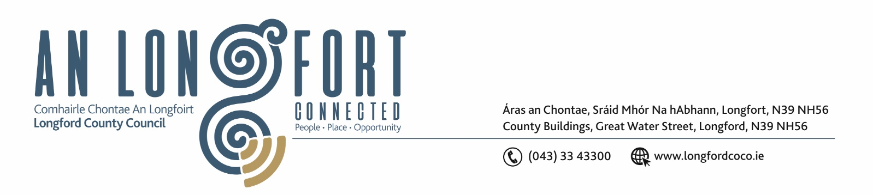

Please note meeting commencing at 3.30 p.m. with presentation on the draft River Basin Management Plan

4u Deireadh Fomhair 2017

Chuig: Gach Ball don Chomhairle.

A Chomhairleoir,

Iarrtar ort bheith i láthair ag Cruinniú Míosuil Chomhairle Chontae Longfoirt a tionólfar i Seomra na Comhairle, Aras an Chontae, Longford ar an Chéadaoin, 11u Deireadh Fomhair 2017 ag 3.30 p.m chun gnó a dhéanamh d’réir an Chláir thíos.

You are requested to attend the Monthly Meeting of Longford County Council to be held in the Council Chamber, Aras an Chontae, Great Water Street, Longford on Wednesday, 11th October 2017 at 3.30 p.m. to transact business, as set out on the Agenda hereunder.

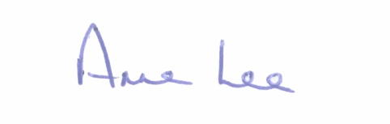
Mise le meas,

__________________
Anne Lee,
Meetings Administrator.

3.30 p.m.

Housing, Infrastructure, Environment & Emergency Services.

Presentation on the draft River Basin Management Plan by South Eastern River Basin District.

4.00 p.m.
C L A R

Prayer before Meeting.

- Confirmation of Minutes of Monthly Meeting of Longford County Council held on the
13th September 2017 – copy enclosed.

2. Matters arising from Minutes.

3. To note Chief Executive Orders. (Summary herewith)

4. To note Monthly Management Report - enclosed.

5. To note adopted Minutes of Corporate Policy Group Meeting held on
12th July 2017 - (copy enclosed).

6. Economic and Community Development, Planning, Human Resources & Corporate Services, Cultural & Recreational Services.

- To note Planning Applications received since September meeting of the Council.

- (i) To note adopted Minutes of Planning and Development and Cultural Strategic Policy Committee Meeting held on the 22nd May 2017.
(ii) To note adopted Minutes of Economic Development and Enterprise Strategic Policy Committee Meeting held the 15th May 2017.

- Update on Regeneration Programme.

- Preparation of Register of Electors.

- Funding for Festivals - Correspondence from Failte Ireland.

- Draft National Planning Framework - report enclosed.

- Interim Guidelines for Planning Authorities on Statutory Plans, Renewable Energy and Climate Change and Wind Energy Development Guidelines 2006 – Update on Review.

- Notices of Motions, submitted by Councillors, as listed hereunder -

Councillor Gerry Warnock.

“I am proposing that Longford County Council write to Deputy Shane Ross, Minister for Transport, Tourism & Sport and ask him to direct Failte Ireland to adapt the terms and reference of their Regional Festivals and Participative Events Fund to ensure that each Local Authority receive a fair portion of the €3.7m fund by setting a minimum allocation of €50,000 per Local Authority.
It is completely unacceptable that Longford’s allocation is a mere €2,000 or 0.05% of the national fund.
The current methodology discriminates against counties like Longford who are being penalised because of lack of accommodation despite the efforts being made by the local authority and many community groups to expand the tourism product within the county.
It is my assertion that counties who are in the process of developing their tourism potential are more in need of funding from national agencies than the already established tourist destinations who after decades of national investment and focus are at a stage where they can attract massive corporate funding to fuel their events.
I am asking that this motion be forwarded to the AILG, LAMA, CCMA and to our Constituency TD’s.”

7. Finance & Information Systems.
(a) To note Public Liability Claims received during September 2017 – report enclosed.

(b) Consideration of Overdraft Accommodation of €5.5m for year ending 31st December 2018.

8. General

- Correspondence – circulated.

- Correspondence received from the Office of the Minister for Health regarding car parking in hospitals for cancer patients.

9. Votes of sympathy.

10. Training -
Consideration of Report from Corporate Policy Group.



